Practice Assignment 4 – Selection Statements

- Create a Planter Robot that will travel over a field of crops and plant a Thing only on intersections that don’t already have a Thing.
  - Include a method that will move the Planter to the next row regardless of the direction it’s facing.

Hint: You may want to modify your Harvester Robot

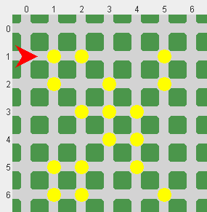
Sample Field:

